Bicupola

Definition
# Source: AI Source: Provided by: [Data Path: Persons Table -> ID Column: 1, Name_En Column: Motasem Essam] -> From: [ChatGPT] on [7/25/2026]
A Bicupola is a polyhedron formed by joining two cupolas together at their larger polygonal bases. The two cupolas are connected base-to-base, leaving their smaller polygonal faces at opposite ends of the solid.
Each cupola consists of:
- One regular $n$-gonal top face.
- One regular $2n$-gonal base.
- $n$ triangular lateral faces.
- $n$ square lateral faces.
When two cupolas are joined along their $2n$-gonal bases, the resulting bicupola has two opposite $n$-gonal faces, $2n$ triangular faces, and $2n$ square faces.

Geometric Structure
# Source: AI Source: Provided by: [Data Path: Persons Table -> ID Column: 1, Name_En Column: Motasem Essam] -> From: [ChatGPT] on [7/25/2026]
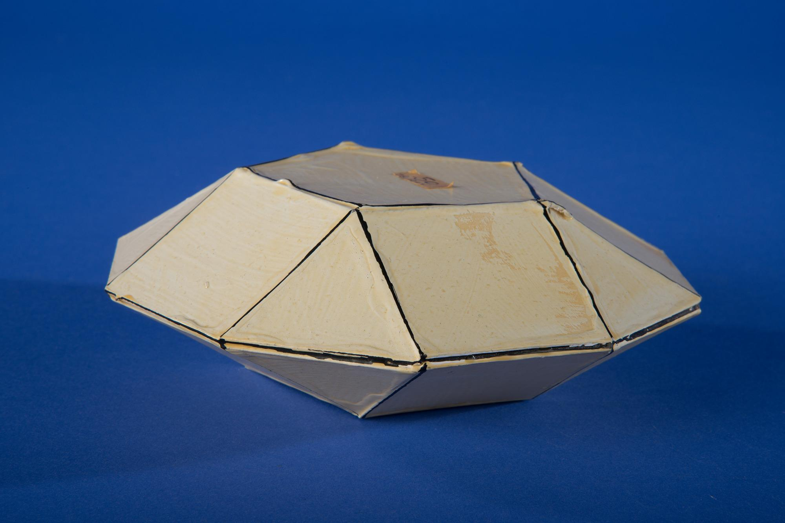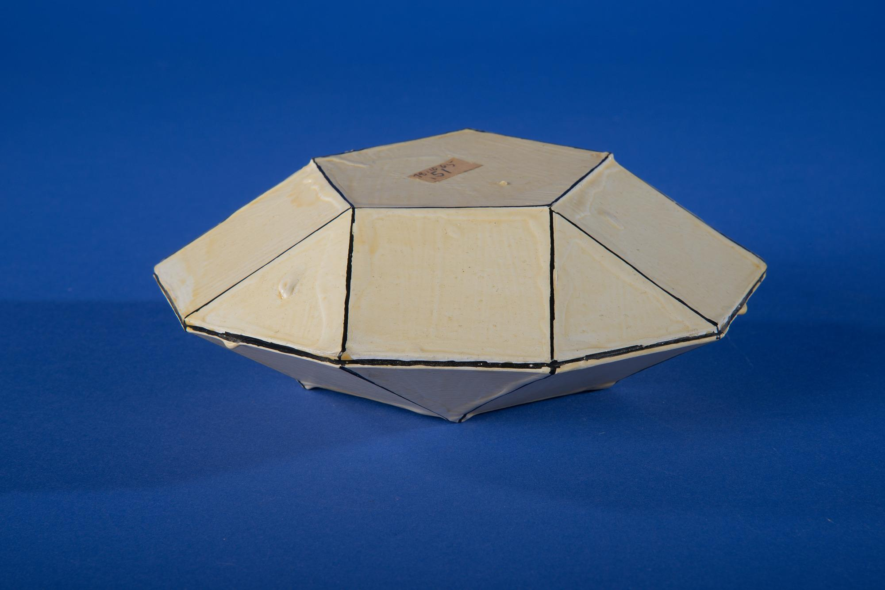
Its main elements are:
- Upper Polygonal Face: The smaller polygon at the top.
- Lower Polygonal Face: The smaller polygon at the bottom.
- Upper Cupola: The upper half of the bicupola.
- Lower Cupola: The lower half of the bicupola.
- Triangular Faces: $2n$ triangular faces distributed between the two cupolas.
- Square Faces: $2n$ square faces distributed between the two cupolas.
- Central Joining Region: The shared $2n$-gonal base where the two cupolas are connected.
- Vertices: The points where three or more edges meet.
- Edges: The line segments forming the boundaries of the polygonal faces.
- Height: The perpendicular distance between the two opposite polygonal faces.

Face Composition
# Source: AI Source: Provided by: [Data Path: Persons Table -> ID Column: 1, Name_En Column: Motasem Essam] -> From: [ChatGPT] on [7/25/2026]
For an $n$-gonal bicupola:
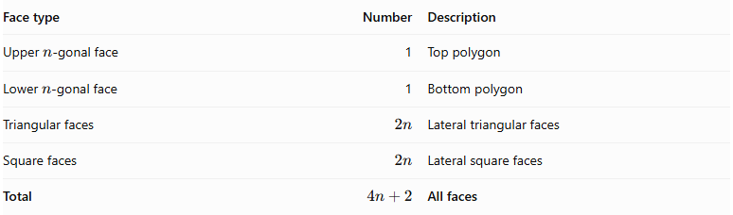
Face type | Number | Description
Upper $n$-gonal face | 1 | Top polygon
Lower $n$-gonal face | 1 | Bottom polygon
Triangular faces | $$2n$$ | Lateral triangular faces
Square faces | $$2n$$ | Lateral square faces
Total | $$4n+2$$ | All faces
The two large $2n$-gonal joining bases are internal to the construction and are not counted as external faces.

Mathematical Properties
# Source: AI Source: Provided by: [Data Path: Persons Table -> ID Column: 1, Name_En Column: Motasem Essam] -> From: [ChatGPT] on [7/25/2026]
For a standard $n$-gonal bicupola:
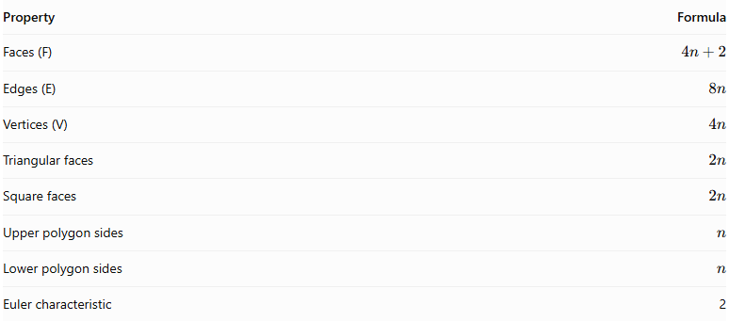
Property | Formula
Faces (F) | $$4n+2$$
Edges (E) | $$8n$$
Vertices (V) | $$4n$$
Triangular faces | $$2n$$
Square faces | $$2n$$
Upper polygon sides | $$n$$
Lower polygon sides | $$n$$
Euler characteristic | 2
Euler's Formula:
$$V-E+F=2$$
Substituting the general formulas:
$$4n-8n+(4n+2)=2$$
Example: Pentagonal Bicupola
For $n=5$:
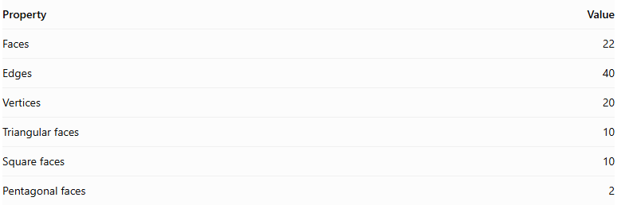
Property | Value
Faces | 22
Edges | 40
Vertices | 20
Triangular faces | 10
Square faces | 10
Pentagonal faces | 2
$$20-40+22=2$$

Types of Bicupolas
# Source: AI Source: Provided by: [Data Path: Persons Table -> ID Column: 1, Name_En Column: Motasem Essam] -> From: [ChatGPT] on [7/25/2026]
Bicupolas are primarily classified according to the relative rotational orientation of their two cupolas.

Orthobicupola
# Source: AI Source: Provided by: [Data Path: Persons Table -> ID Column: 1, Name_En Column: Motasem Essam] -> From: [ChatGPT] on [7/25/2026]
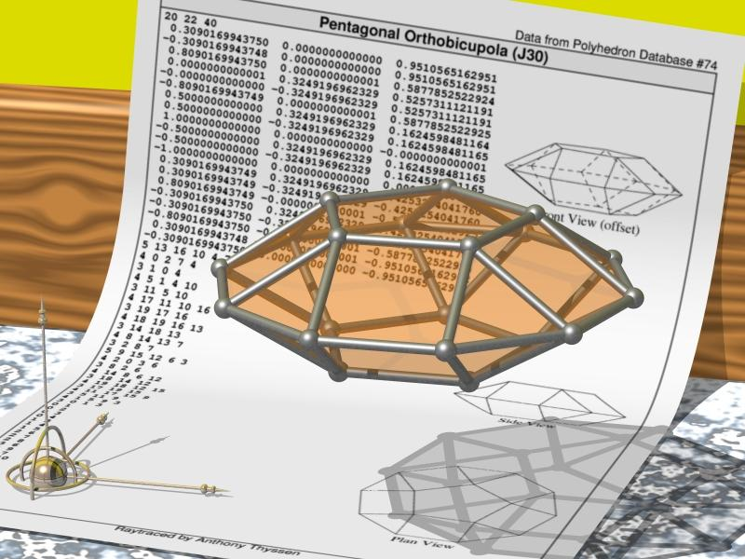
An Orthobicupola is formed by joining two cupolas base-to-base with their corresponding lateral face arrangements aligned in the same orientation.
- The two cupolas have matching orientations.
- Their larger polygonal bases are joined together.
- The resulting solid has rotational and reflectional symmetry.

Gyrobicupola
# Source: AI Source: Provided by: [Data Path: Persons Table -> ID Column: 1, Name_En Column: Motasem Essam] -> From: [ChatGPT] on [7/25/2026]
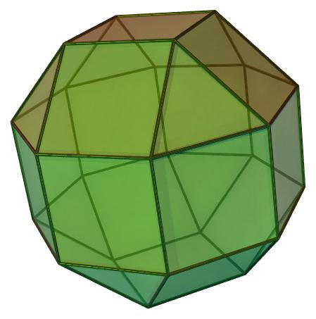
A Gyrobicupola is formed by joining two cupolas base-to-base after rotating one cupola relative to the other.
- The two cupolas have a rotated relative orientation.
- Their triangular and square face arrangements are offset.
- The resulting solid has a different symmetry arrangement from the corresponding orthobicupola.
For a regular $n$-gonal cupola, the characteristic relative rotation is ${180}^{∘}/n$. For example, the pentagonal gyrobicupola uses a ${36}^{∘}$ rotation.

Examples of Bicupolas
# Source: AI Source: Provided by: [Data Path: Persons Table -> ID Column: 1, Name_En Column: Motasem Essam] -> From: [ChatGPT] on [7/25/2026]
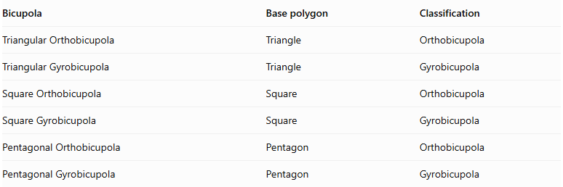
Bicupola | Base polygon | Classification
Triangular Orthobicupola | Triangle | Orthobicupola
Triangular Gyrobicupola | Triangle | Gyrobicupola
Square Orthobicupola | Square | Orthobicupola
Square Gyrobicupola | Square | Gyrobicupola
Pentagonal Orthobicupola | Pentagon | Orthobicupola
Pentagonal Gyrobicupola | Pentagon | Gyrobicupola
Important: Some special bicupolas coincide with other well-known polyhedra. For example, the triangular gyrobicupola is the cuboctahedron. The square and pentagonal orthobicupolas and gyrobicupolas include examples among the Johnson solids.

Geometric Characteristics
# Source: AI Source: Provided by: [Data Path: Persons Table -> ID Column: 1, Name_En Column: Motasem Essam] -> From: [ChatGPT] on [7/25/2026]
- It is formed by joining two cupolas at their larger polygonal bases.
- It has two opposite $n$-gonal faces.
- It contains $2n$ triangular faces.
- It contains $2n$ square faces.
- It has $4n+2$ faces in total.
- It has $8n$ edges.
- It has $4n$ vertices.
- Its two cupolas may have aligned or rotated orientations.
- It is a polyhedron with a polygonal surface.
- Regular convex examples can belong to the Johnson-solid family.

Geometric Construction
# Source: AI Source: Provided by: [Data Path: Persons Table -> ID Column: 1, Name_En Column: Motasem Essam] -> From: [ChatGPT] on [7/25/2026]
- Construct the first cupola with a regular $n$-gonal top face and a regular $2n$-gonal base.
- Construct a second cupola with the same base polygon.
- Position the two cupolas so that their larger bases face each other.
- Join the two $2n$-gonal bases, removing the internal joining faces from the external surface.
- For an orthobicupola, align the two cupolas.
- For a gyrobicupola, rotate one cupola relative to the other by ${180}^{∘}/n$.
- Complete the solid and identify its external faces, edges, and vertices.

Construction of a Bicupola

Geometric Instruments Used
# Source: AI Source: Provided by: [Data Path: Persons Table -> ID Column: 1, Name_En Column: Motasem Essam] -> From: [ChatGPT] on [7/25/2026]
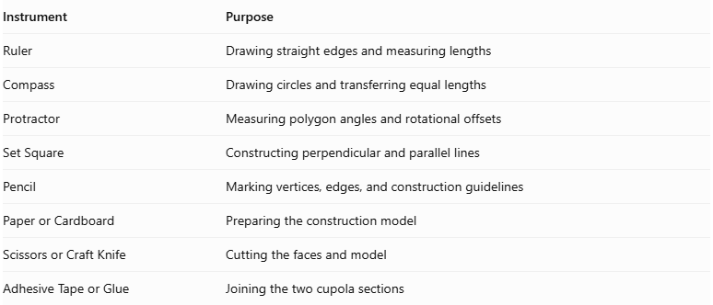
Instrument | Purpose
Ruler | Drawing straight edges and measuring lengths
Compass | Drawing circles and transferring equal lengths
Protractor | Measuring polygon angles and rotational offsets
Set Square | Constructing perpendicular and parallel lines
Pencil | Marking vertices, edges, and construction guidelines
Paper or Cardboard | Preparing the construction model
Scissors or Craft Knife | Cutting the faces and model
Adhesive Tape or Glue | Joining the two cupola sections

Instrument-Based Construction Procedures

Constructing the First Cupola
# Source: AI Source: Provided by: [Data Path: Persons Table -> ID Column: 1, Name_En Column: Motasem Essam] -> From: [ChatGPT] on [7/25/2026]
- Determine the number of sides $n$ of the smaller polygonal base.
- Construct a regular $2n$-sided polygon to serve as the joining base.
- Construct a smaller regular $n$-sided polygon parallel to the joining base.
- Arrange the vertices of the smaller polygon according to the cupola structure.
- Construct $n$ triangular faces and $n$ square faces between the two polygonal bases.
- Check the edge lengths and face connections.

Constructing the Second Cupola
# Source: AI Source: Provided by: [Data Path: Persons Table -> ID Column: 1, Name_En Column: Motasem Essam] -> From: [ChatGPT] on [7/25/2026]
- Construct a second cupola with the same dimensions and face arrangement as the first.
- Ensure that its larger polygonal base matches the first cupola's joining base.
- Check that both cupolas have compatible edge lengths.
- Prepare the second cupola for the selected orientation.

Joining the Two Cupolas
# Source: AI Source: Provided by: [Data Path: Persons Table -> ID Column: 1, Name_En Column: Motasem Essam] -> From: [ChatGPT] on [7/25/2026]
- Position the two larger polygonal bases against each other.
- Align the corresponding vertices and edges for an orthobicupola.
- Alternatively, rotate one cupola by half of one angular interval of the $2n$-sided joining polygon for a gyrobicupola.
- Match the two joining boundaries.
- Join the two cupolas along their larger polygonal bases.
- Treat the shared polygonal base as an internal face, not an external face.
For a regular $2n$-gon, the central angle is:
$$θ=\frac{{360}^{°}}{2n}=\frac{{180}^{°}}{n}$$
Thus, the half-step rotational offset for the gyrobicupola is:
$$\boxed{α=\frac{{90}^{°}}{n}}$$

Completing the Solid Drawing
# Source: AI Source: Provided by: [Data Path: Persons Table -> ID Column: 1, Name_En Column: Motasem Essam] -> From: [ChatGPT] on [7/25/2026]
- Draw the two smaller polygonal bases at opposite ends.
- Draw the triangular and square lateral faces.
- Represent the central joining region through the connected face arrangement rather than as an external polygonal face.
- Draw visible edges using continuous lines.
- Draw hidden edges using dashed lines where appropriate.
- Check the symmetry and alignment of the completed bicupola.

Related Geometric Solids
# Source: AI Source: Provided by: [Data Path: Persons Table -> ID Column: 1, Name_En Column: Motasem Essam] -> From: [ChatGPT] on [7/25/2026]
- Cupola
- Triangular Cupola
- Square Cupola
- Pentagonal Cupola
- Rotunda
- Orthobicupola
- Gyrobicupola
- Elongated Bicupola
- Gyroelongated Bicupola
- Prism
- Antiprism

Main Classification
# Source: AI Source: Provided by: [Data Path: Persons Table -> ID Column: 1, Name_En Column: Motasem Essam] -> From: [ChatGPT] on [7/25/2026]
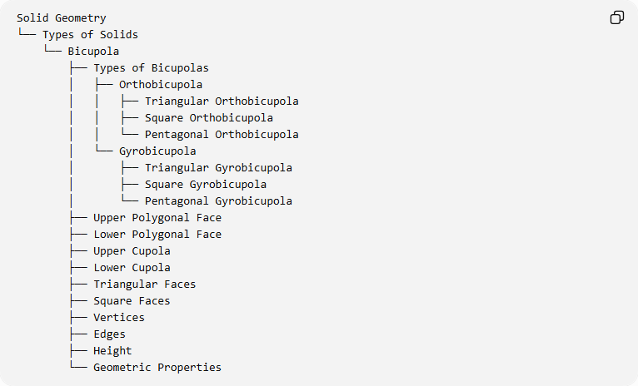
Solid Geometry
└── Types of Solids
└── Bicupola
├── Types of Bicupolas
│ ├── Orthobicupola
│ │ ├── Triangular Orthobicupola
│ │ ├── Square Orthobicupola
│ │ └── Pentagonal Orthobicupola
│ └── Gyrobicupola
│ ├── Triangular Gyrobicupola
│ ├── Square Gyrobicupola
│ └── Pentagonal Gyrobicupola
├── Upper Polygonal Face
├── Lower Polygonal Face
├── Upper Cupola
├── Lower Cupola
├── Triangular Faces
├── Square Faces
├── Vertices
├── Edges
├── Height
└── Geometric Properties

Key Points
# Source: AI Source: Provided by: [Data Path: Persons Table -> ID Column: 1, Name_En Column: Motasem Essam] -> From: [ChatGPT] on [7/25/2026]
- A bicupola is formed by joining two cupolas at their larger polygonal bases.
- It has two opposite $n$-gonal faces.
- It contains $2n$ triangular faces and $2n$ square faces.
- Its two main types are Orthobicupola and Gyrobicupola.
- Its general face, edge, and vertex counts are $4n+2$, $8n$, and $4n$, respectively.
- It belongs to the family of polyhedra.

Conclusion
# Source: AI Source: Provided by: [Data Path: Persons Table -> ID Column: 1, Name_En Column: Motasem Essam] -> From: [ChatGPT] on [7/25/2026]
The Bicupola is a polyhedron constructed by joining two cupolas base-to-base. Its structure is characterized by two opposite polygonal faces, triangular lateral faces, and square lateral faces. Its two principal forms, Orthobicupola and Gyrobicupola, are distinguished by the relative orientation of their component cupolas.

